PROJECT REPORT
on
Face Recognition Attendance System
(CSE VI Semester Mini project PCS-504)
2020-2021

Submitted to: Submitted by:
Mr. Avnish Panwar Priyanka Lohani
(CC-CSE-B-VI-Sem) Roll. No.: 1018550
Guided by: CSE-B-VI-Sem
Mr. Akash Chauhan Session: 2020-2021
(Resource Person)

DEPARTMENT OF COMPUTER SCIENCE AND INFORMATION TECHNOLOGY
GRAPHIC ERA HILL UNVERSITY, DEHRADUN
CERTIFICATE

Certified that Priyanka Lohani (Roll No.- 1018550) has developed mini project on “Face Recognition Attendance System” for the CS VI Semester Mini Project Lab (PCS-504) in Graphic Era Hill University, Dehradun. The project carried out by Students is their own work as best of my knowledge.

Date:14-5-2021

(Mr. Avnish Panwar)
Project Co-ordinator
CC-CSE-B-VI-Sem
(CSE Department)
GEHU Dehradun

(Mr. Akash Chauhan)
Project Guide
Resource Person
(CSE Department)
GEHU Dehradun

ACKNOWLEDGMENT

I wish to thank my parents for their continuing support and encouragement. I also wish to thank them for providing us with the opportunity to reach this far in our studies.
I would like to thank particularly our project Co-ordinator Mr. Avnish Panwar and our Project Guide Mr. Akash Chauhan for his patience, support and encouragement throughout the completion of this project and having faith in us.
At last but not the least I greatly indebted to all other persons who directly or indirectly helped us during this work.

Priyanka Lohani
Roll No.- 1018550
CSE-B-VI-Sem
Session: 2020-2021
GEHU, Dehradun
TABLE OF CONTENTS

CHAPTER NO. TITLE PAGE NO.
LIST OF DATA vi

1. INTRODUCTION 8
1.1 About Project 8
1.2 About Face recognition 8

2. PROJECT 10
2.1 Requirement Analysis 10
2.2 Software Specification 10
2.3 Module 10
2.4.1 Collection and Storing of Data 10
2.4.2 Encoding Of Images 11
2.4.3. Recognizing the faces 11
2.4.4 Marking Attendance 11
2.4.5 Creating email id 11

3. SNAPSHOT OF PROJECT 12
3.1 Registered and Unregistered students 12
3.2 Email sent to the Absentees 13 3.3. Attendance marked in the Attendance file 14

4. CONCLUSION 15
4.1 SUMMARY 15
4.2 FUTURE WORKS 15
REFERENCE 18

LIST OF DATA

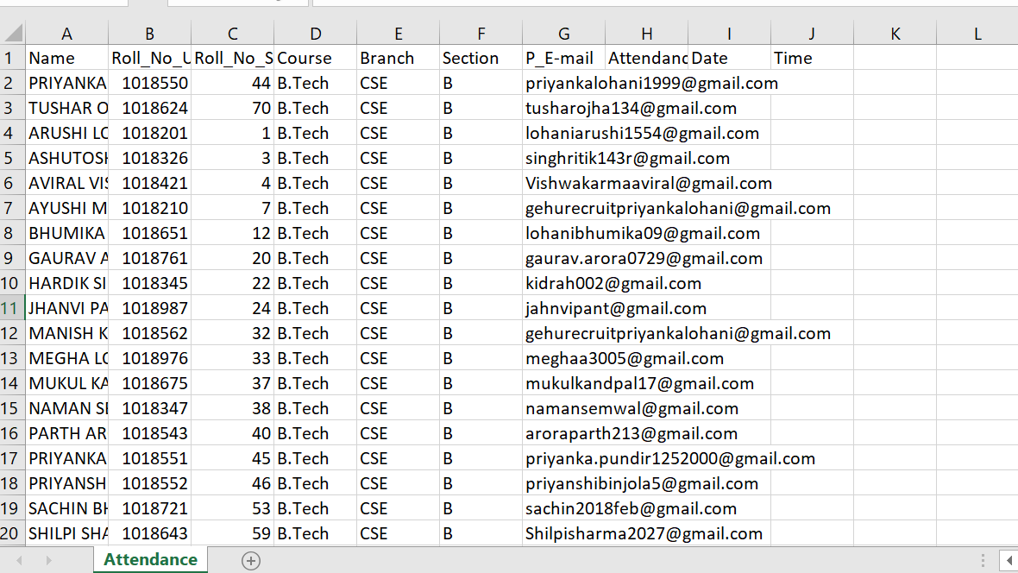

CHAPTER 1
INTRODUCTION

  - ABOUT PROJECT
Maintaining attendance is compulsory and important in all the institutions for knowing the performance of students. This attendance constitutes a major role for students because based on these students get their final grade by the end of their semester for these the students attend their classes without any fail. This is the main factor in improving the education standard. So for these reasons the teacher has to mark the attendance carefully without making any wrong attendance and before completing taking of attendance should make sure whether marked attendance correctly .This is also a time waste process for teachers because of taking attendance manually. But it is very difficult when there is more number of students. So different colleges so follow different methods and some take attendance by using files and some others take attendance by using biometric systems. Other method that is used is by manually signing of students on papers. Whenever they are attending the classes
this takes much tie for finding their names on the sheet and there may be chance they may lost the sheet.

  - ABOUT FACE RECOGNITION
Recognizing people by their faces in pictures and video feeds is seen everywhere starting from social media to phone cameras. A face recognition system is built for matching human faces with a digital image. Ultimately what a computer recognizes is pixel values ranging from 0-255. In Computer Vision face recognition has been in since ages and has evolved over the years. Many researchers have come up with many new techniques to efficiently identify and tell apart faces. There are many use cases such as authentication and verification of users.
CHAPTER 2
PROJECT

2.1 REQUIREMENT ANALYSIS
The main aim of this project is to build an Attendance system using face recognition.

2.2 SOFTWARE SPECIFICATION

- Windows 10
- Python 3
- Python libraries like:
- numpy
- pandas
- face_recognition
- cv2
- os
- datetime
- email_to

2.2 MODULES
2.2.1 COLLECTION AND STORING OF DATA
- In this we will collect the information like name,roll.no,section and email id of the students and will store them in a csv file named student info.
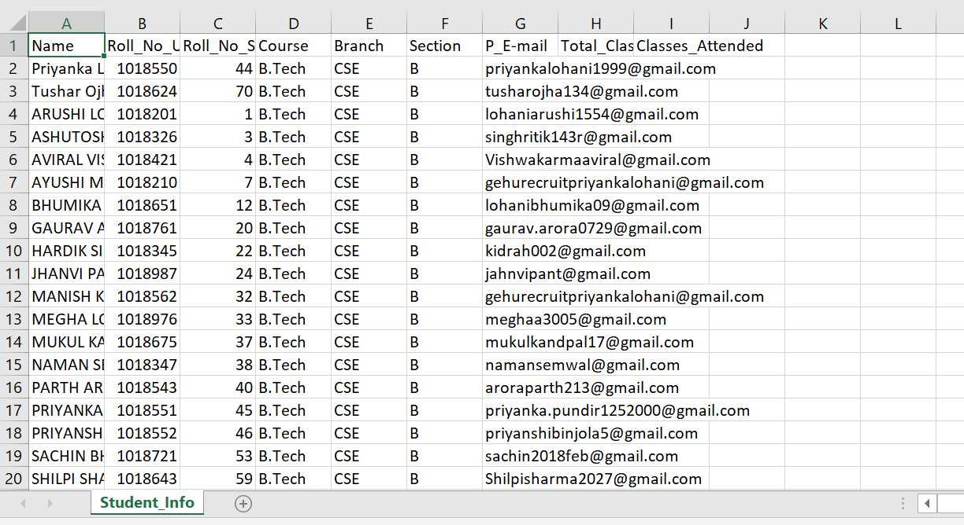

- Then we will copy this information to other file named Attendance where will will be able to see if the person is absent or present on that particular day.
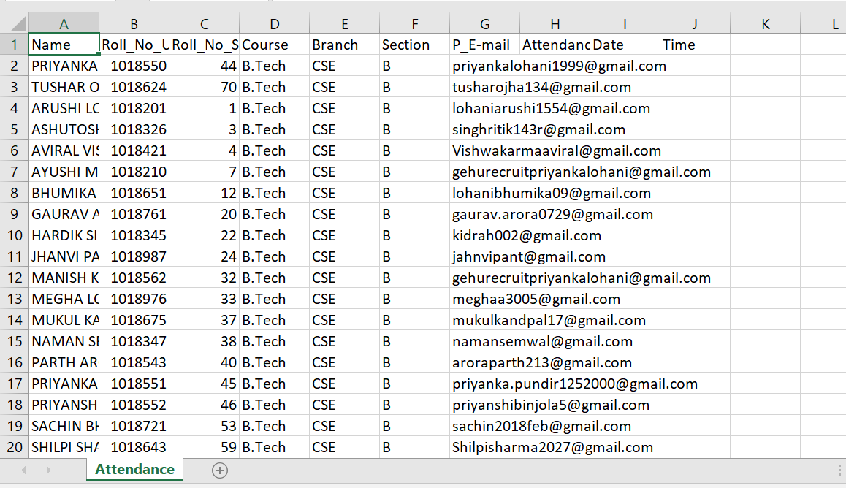
- Then we will also make one folder and insert all the images of children with their Roll.no and section.
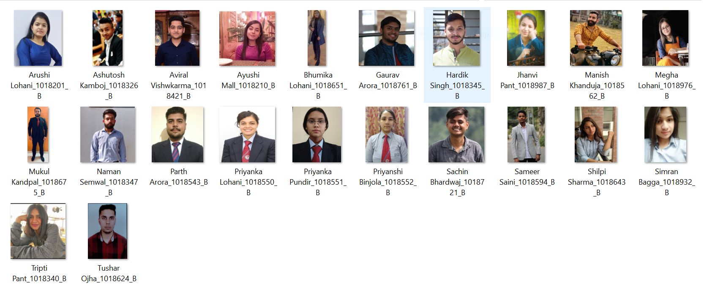

2.2.2 ENCODING OF IMAGES

In encoding of image-we will find features of the image and this we will find with the help of
dilib module of face_recognition library.
Then we will start storing the encodings in a list and later on match the faces with these encodings.

2.2.3 RECOGNIZING THE FACES

- In this we will access the video through our webcam and analyse each frame of the video. We will find face location and match it with the encoding list that we have created.

- If the face is recognized we will print the name on screen else we will print unregistered.

2.2.4 MARKING THE ATTENDANCE

- If the face is matched with the database and is more than 50%, we will show the name of that person in the video frame and mark him present in our attendance sheet and we will also record the date and time of the attendance marked.
- We will also update the classes attended and total classes in the main datasheet.

2.2.5 CREATING EMAIL ID

- Then we will create a list of email ids of the absentees and with the help of Google’s email API, we will send a customized email to the parents of each of the student stating theirs ward did not attend the class.
- Then at last we will create a copy of day’s attendance and reset our attendance file.

CHAPTER 3
SNAPSHOT OF PROJECT

3.1 REGISTERED AND UNREGISTERED STUDENTS

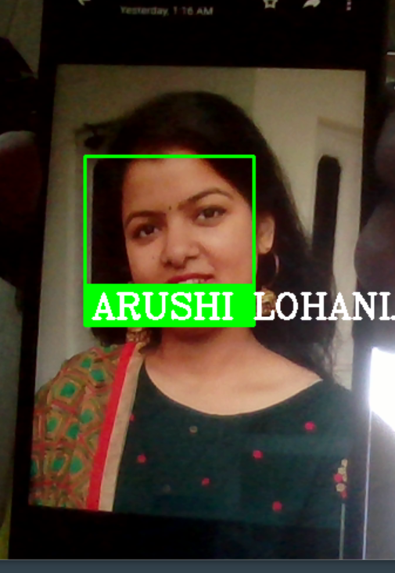

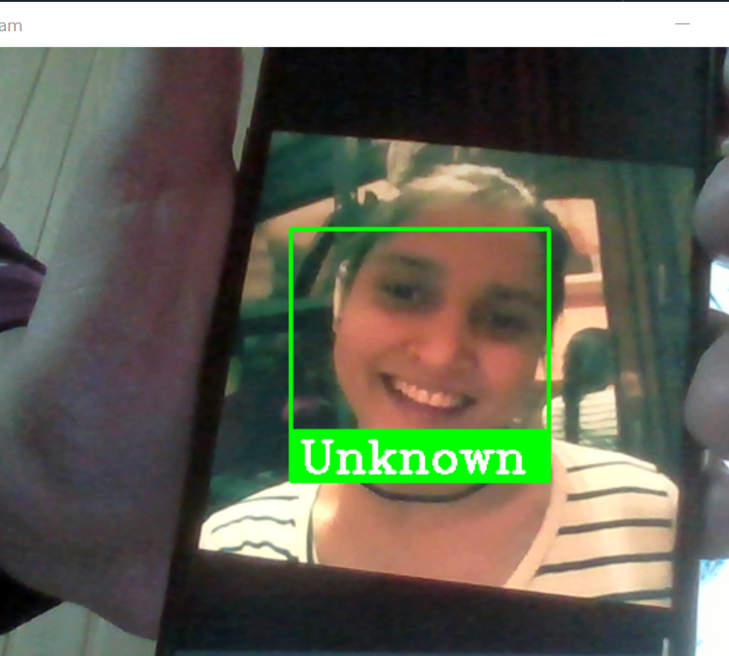
  - EMAIL SENT TO THE ABSENTEES

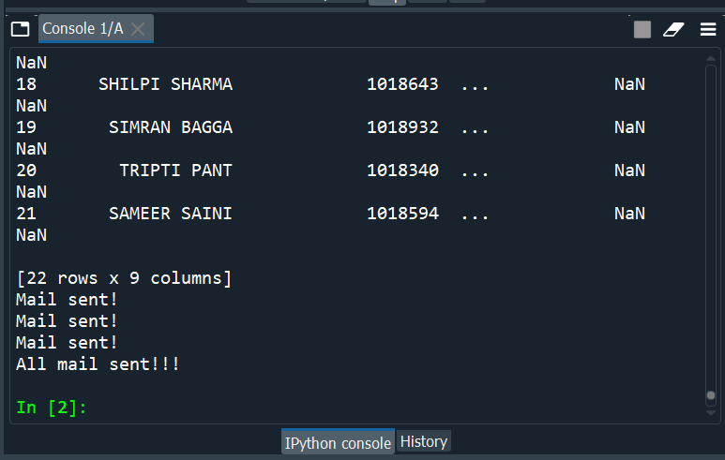


  - ATTENDANCE MARKED IN THE ATTENDANCE FILE

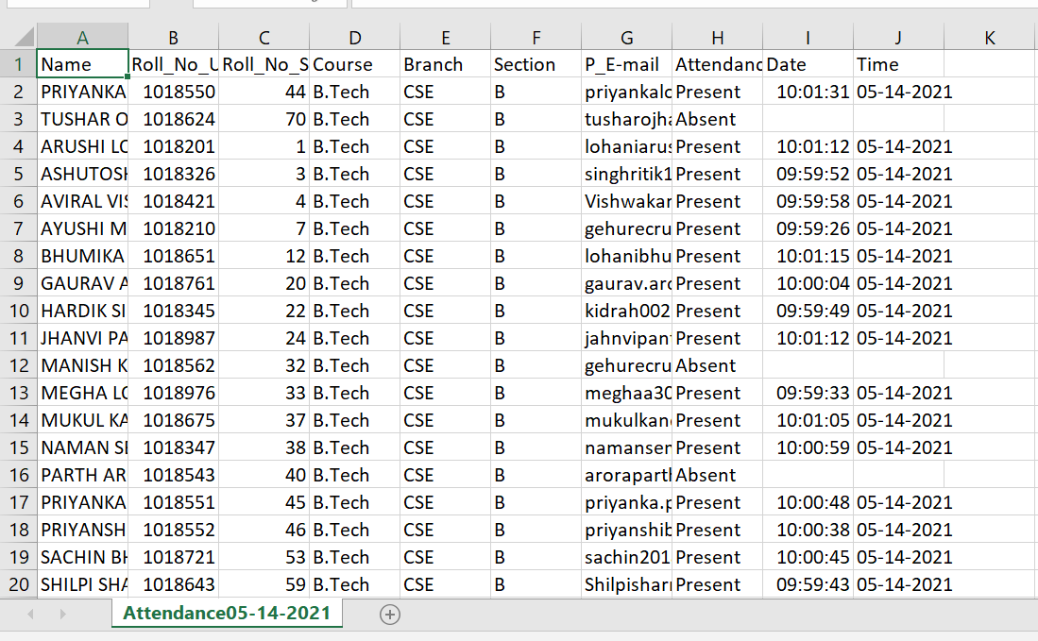

CHAPTER 4
CONCLUSION

4.1 SUMMARY

For a classroom or in any working environment, we will just need few face images of the people we want to register and put them in folders with the folder name being unique to each person. After registering them, we only have to run inference on the video feed of the classroom or the working area. We can change the code a bit and can generate the timestamps for each person identified. In this way we can have an analysis of when that student was in the classroom, it is more suitable for classroom environments as there won’t be any manual work for attendance.

4.2 FUTURE SCOPE

Maintaining attendance automatically with the help of face recognition will be very helpful and less prone to errors as compared to manual process. This will also reduce manipulation of attendance record done by students and it will save time as well.
There may be more enhancements in project like calculating the average attendance of each student and calucating there percentage if they were debarding means attendance would be less than 70% they will be getting mail to attend their classes regularly.

REFERENCE

- OpenCV Documentation: https://docs.opencv.org/master/
- Face recognition documentation: https://facerecognition.readthedocs.io/en/latest/face_recognition.html
- Email to API documentation: https://pypi.org/project/email-to/

-------------------------------------------------------

